Cell Info
Developer Guide

Supervisor. | Miss Esha Shahid
Batch. | 2506F2
Group. | B
Serial No. | Enrollment Number | Student Name
1. | Student 1669168 | Arbash Murtaza
2. | Student 1669153 | Abeera Malik
3. | Student 1672376 | Aafia Naz

- Home (index (1).html)

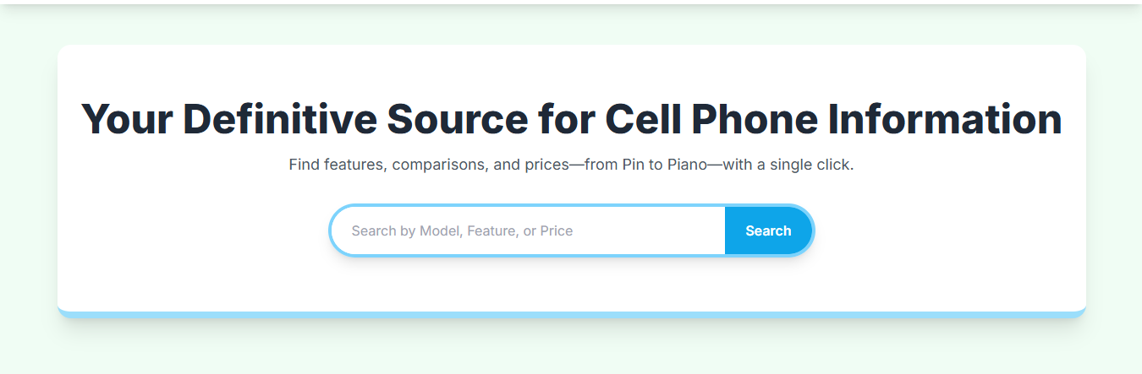

Figure 1: Home page to Cell info
Our main heading on the homepage gives visitors a clear idea about our website’s purpose — “Your Definitive Source for Cell Phone Information.”
● It helps users understand that the website provides complete details about mobile phones, including features, comparisons, and prices.
● The search bar below allows users to search by model, feature, or price, making it easy for them to find what they need instantly.
● By clicking the Search button, users can explore detailed phone information and comparisons in just one click.
Code of Home page

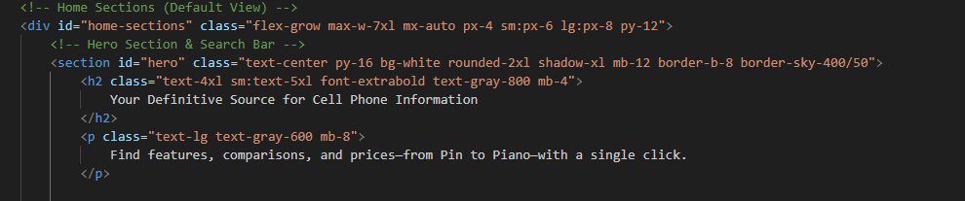
- Navbar (index (1).html)

Figure 2: Navbar
The navigation bar (navbar) is placed at the top of the website and serves as the main menu for user navigation. It provides quick access to all important sections of the website such as Home, About, Contact, Brands, and Models pages.

Code of Navbar

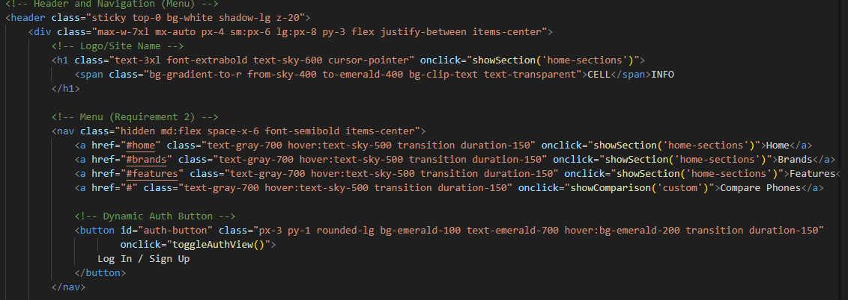

- Brands (index (1).html)

Figure 3: Brands
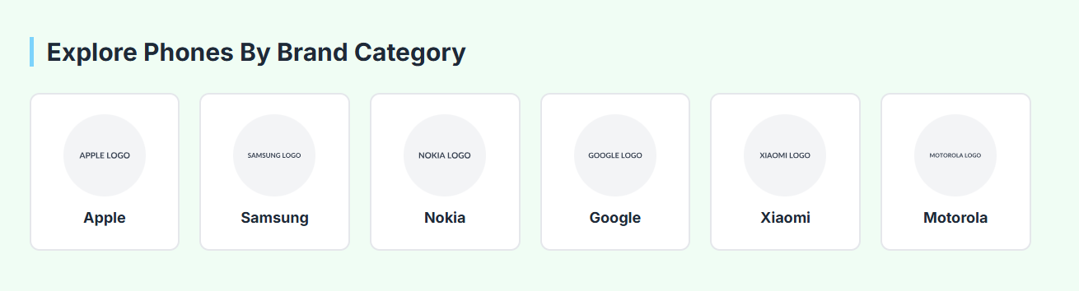

Explore Phones By Brand Category Section
This section allows users to browse mobile phones categorized by popular brands.
Each brand is represented by a card containing the brand logo and brand name.
When a user clicks on a brand’s card, they will be redirected to a dedicated page showing all available phone models from that specific brand..
Code of Brands

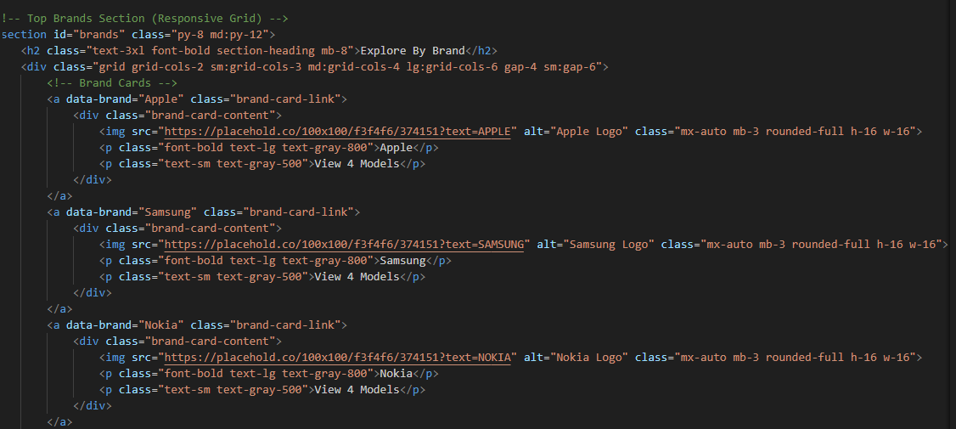

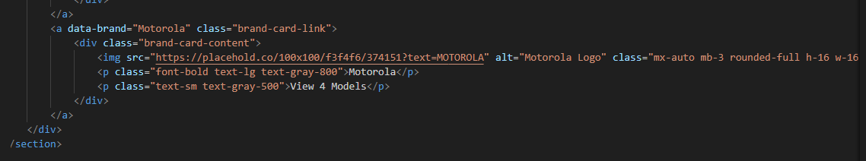
Features (index (1).html)

Figure 4: Features

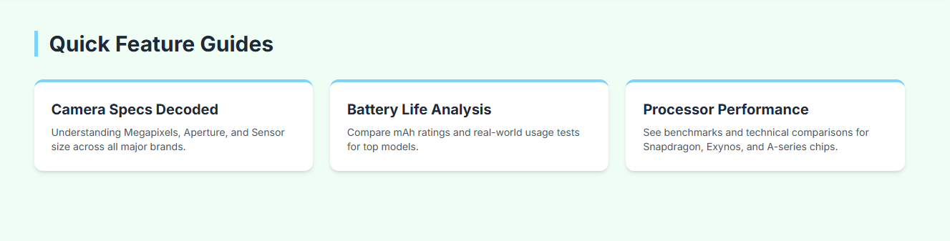

The Feature Comparison part of the Cell Info website helps users compare different mobile phones easily. It shows phone details like RAM, battery, camera, and storage side by side in one table.
This feature is made using HTML, CSS, and JavaScript. When a user selects phones, JavaScript collects their data and displays it in a table where each row shows a feature and each column shows a selected phone. If a feature is missing for any phone, it shows “N/A” instead of leaving it blank.
The table is also responsive, so it looks neat on both large and small screens. This section makes it simple for users to check which phone suits them best, while also showing how JavaScript and DOM are used to create interactive and dynamic web pages.

Code of features

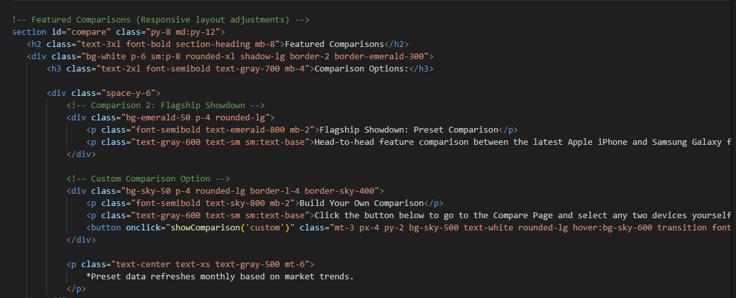
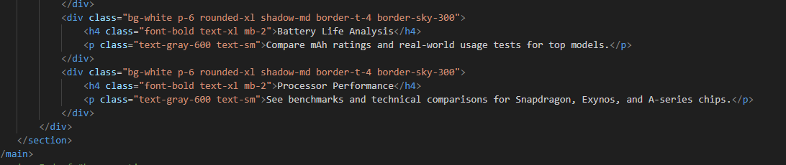

5.Phone comparison (index (1).html

Figure 5: phone comparison

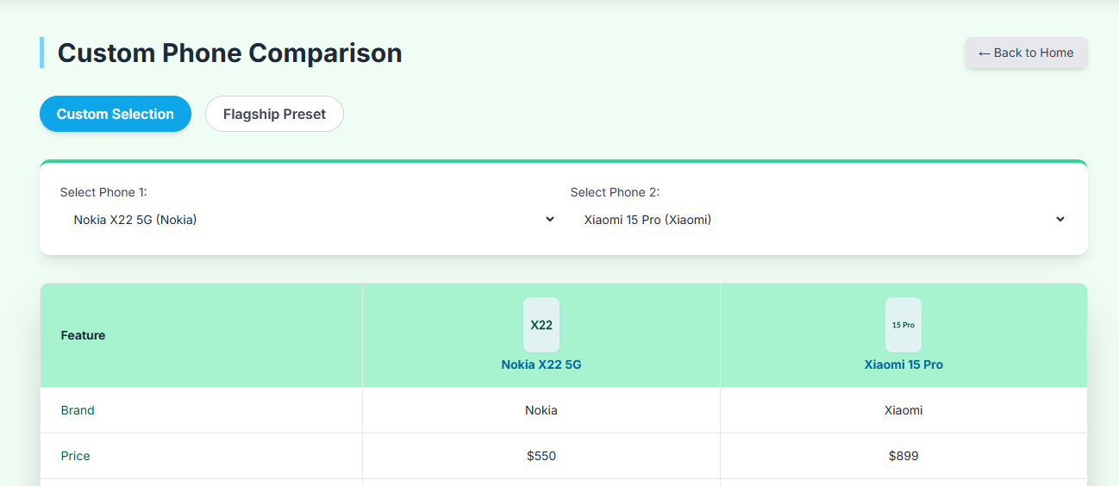

The Comparison Page of the Cell Info website allows users to compare different mobile phones side by side. It is designed using HTML, CSS, and JavaScript to make the comparison interactive and user-friendly.
Users can select up to five phones, and the page automatically displays their features in a structured table format. Each phone’s data is shown clearly so users can easily see differences in RAM, battery, camera, and other specs.
This page improves the website’s usability by helping users make smart choices through direct and visual comparison of phone details.

Code of phone comparison

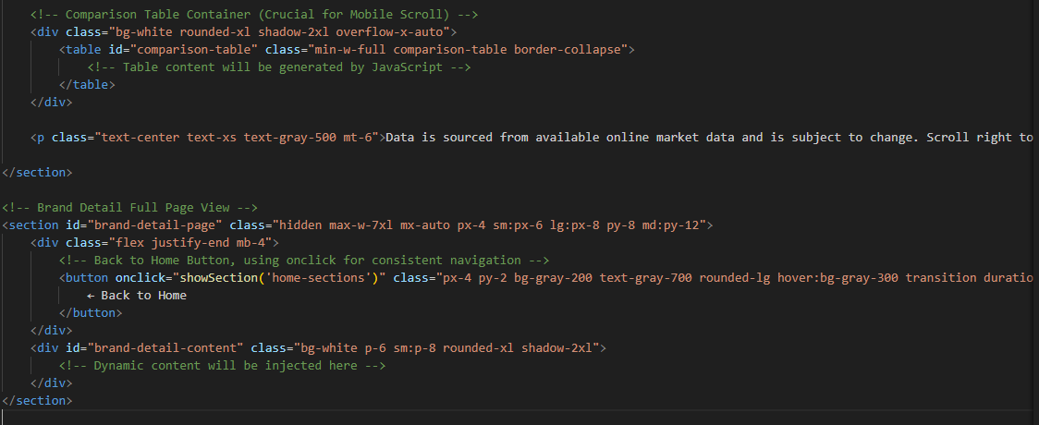

- Menu bar:

Figure 6: Description of our Menu bar

Use to load the remaining sections. The following is a list of those sections:
As we have work on only single page and re-directing on other sections. So we are made our web directed pages.
- Home Page (1. index (1).html)
- Brands Page (2. index (1).html- Brands Section)
- Feature Page (3. index (1).html-features Section)
- Comapre Page (4. index (1).html-compare Section)
Portfolio details(5.Portfolio-detail.html)
Sign in Page (14. index (1).html)
- login Page (15. index (1).html)
- Contact Page (16. index (1).html

- Portfolio (index (1).html):

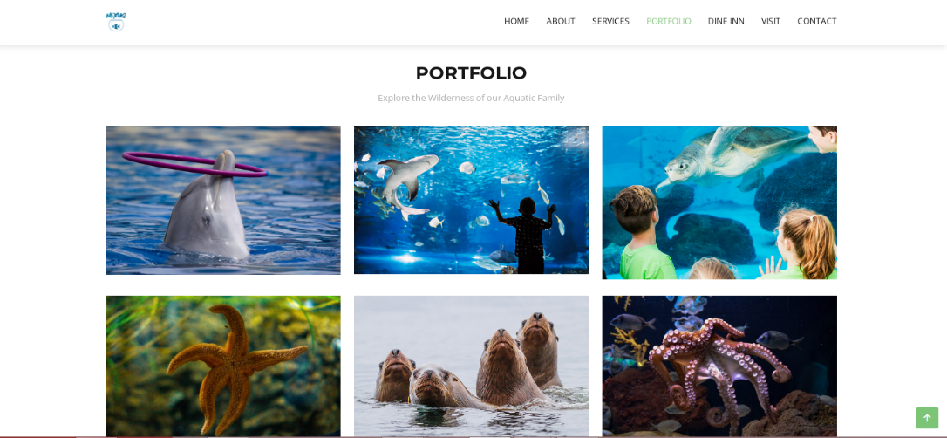



Figure 8: Portfolio

Description:
In Portfolio we have specified about the specific marine animals and we have given the slide-show of the specific fishes to make our website creative and provide people knowledge about marines.
We have created the icon to redirect with the slideshow. We have given the details of the marine.
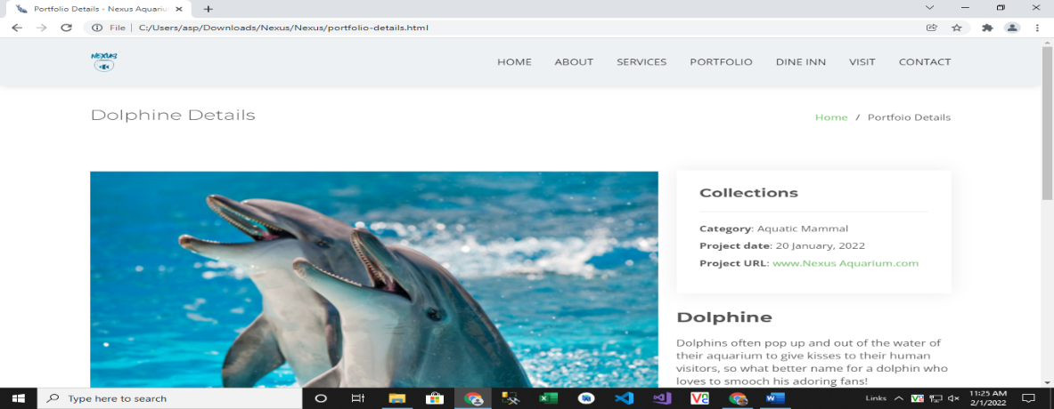
Code of Portfolio
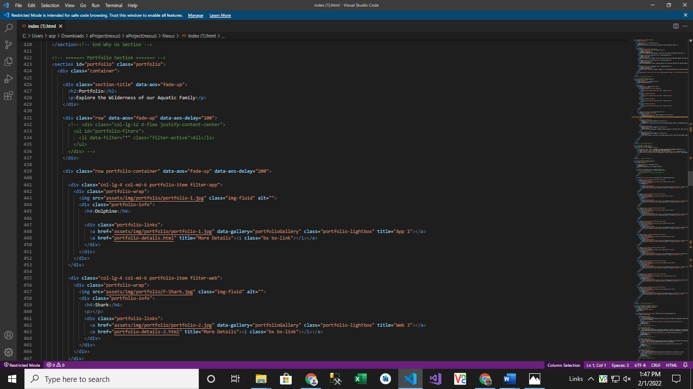
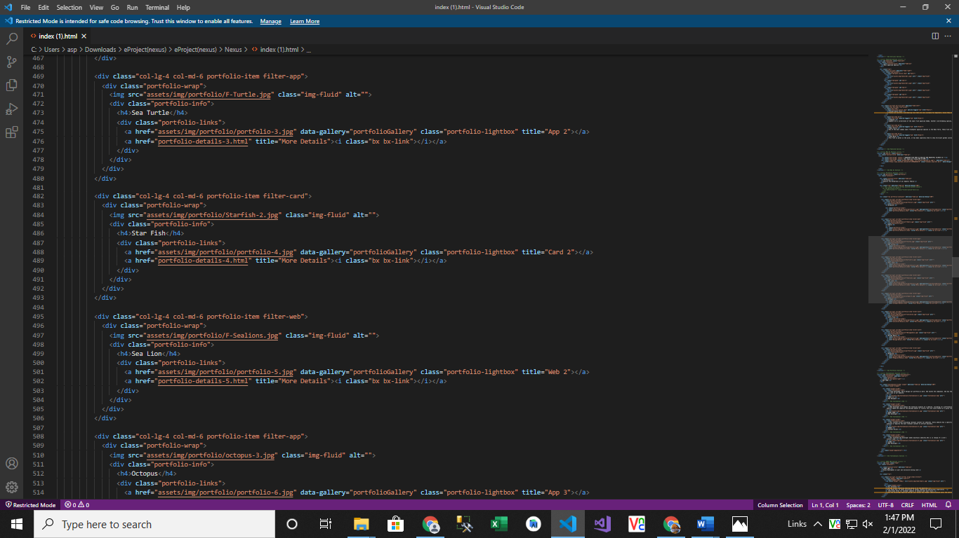
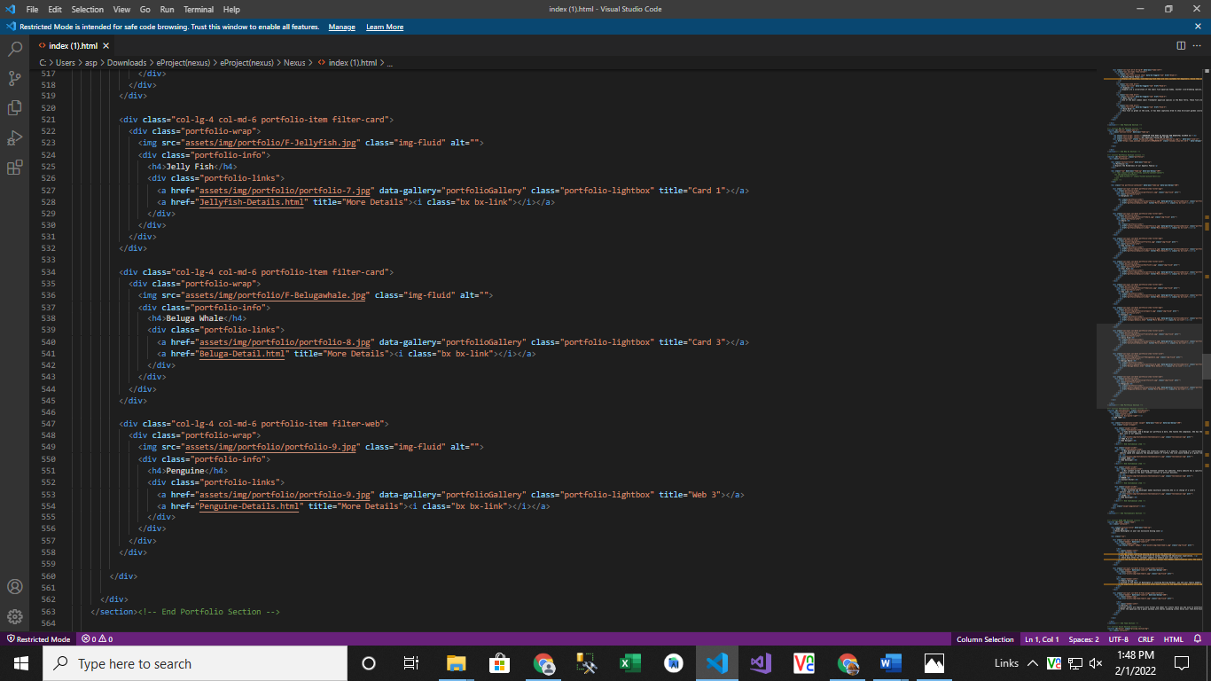

- Our Team (index (1).html):
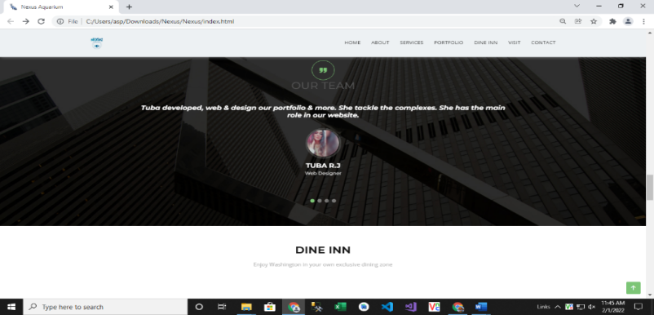

Web Designer
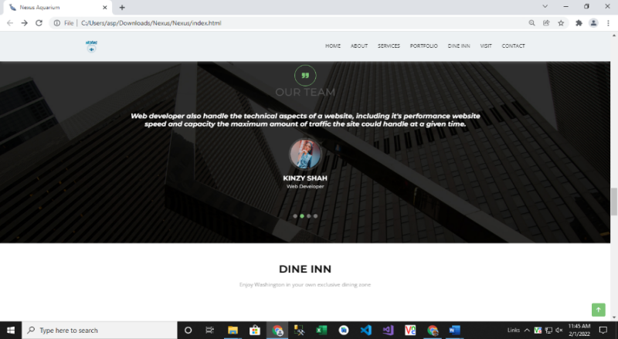

Web Developer
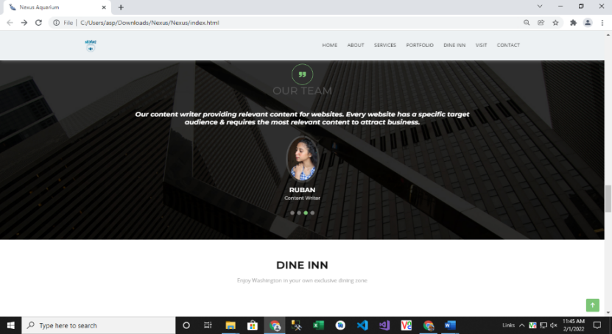

Content Writer
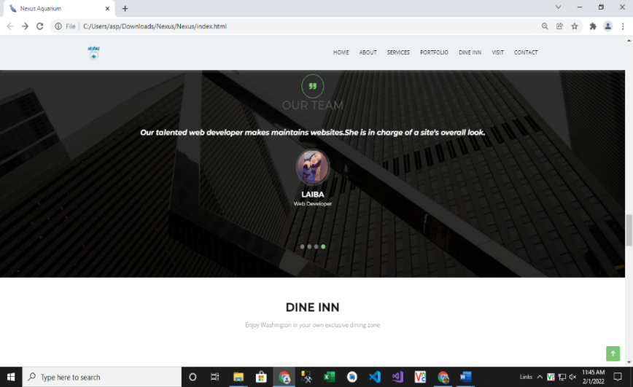

Web Developer
Figure 9: Our Team
Code of Our Team

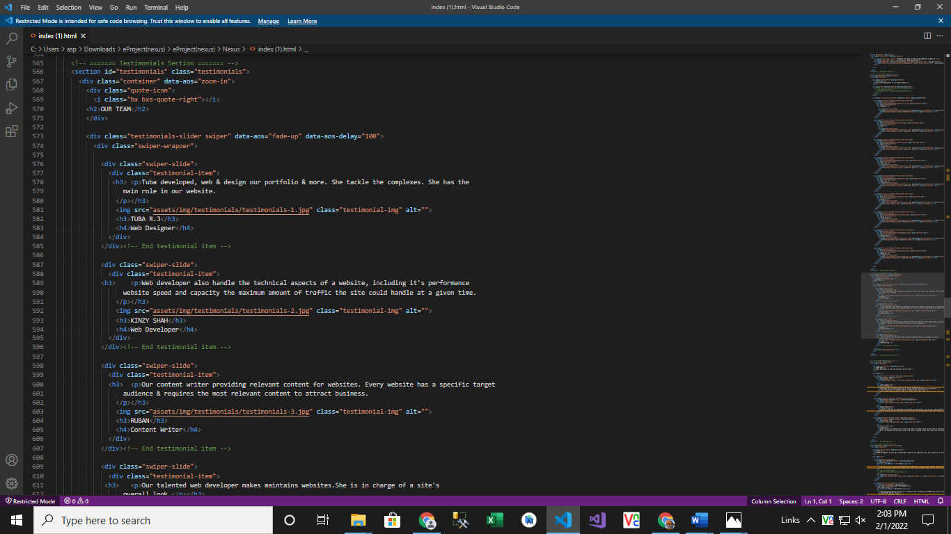

- Dine Inn (index (1).html):

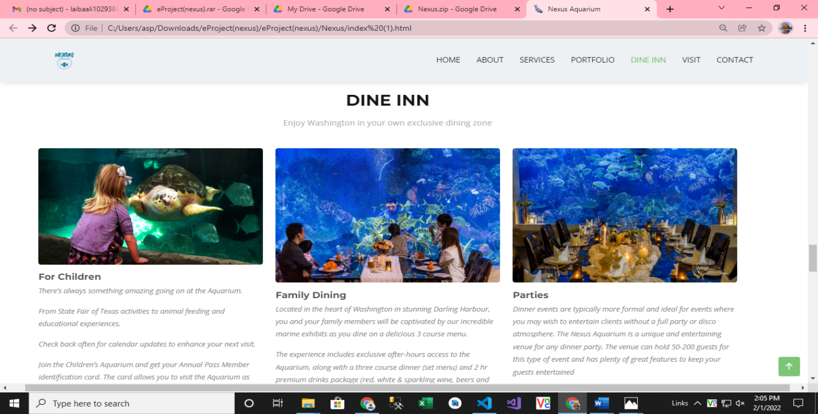

Figure 10: Dine Inn

Our dine inn page is designed to elaborate about our aquatic environment and our timings and other policies are also mentioned there.

Code of Dine Inn
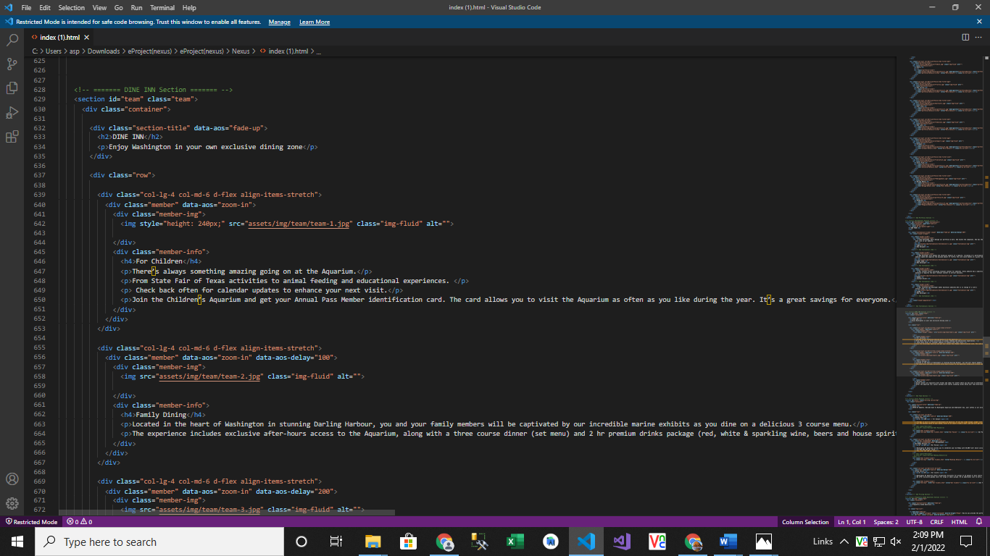
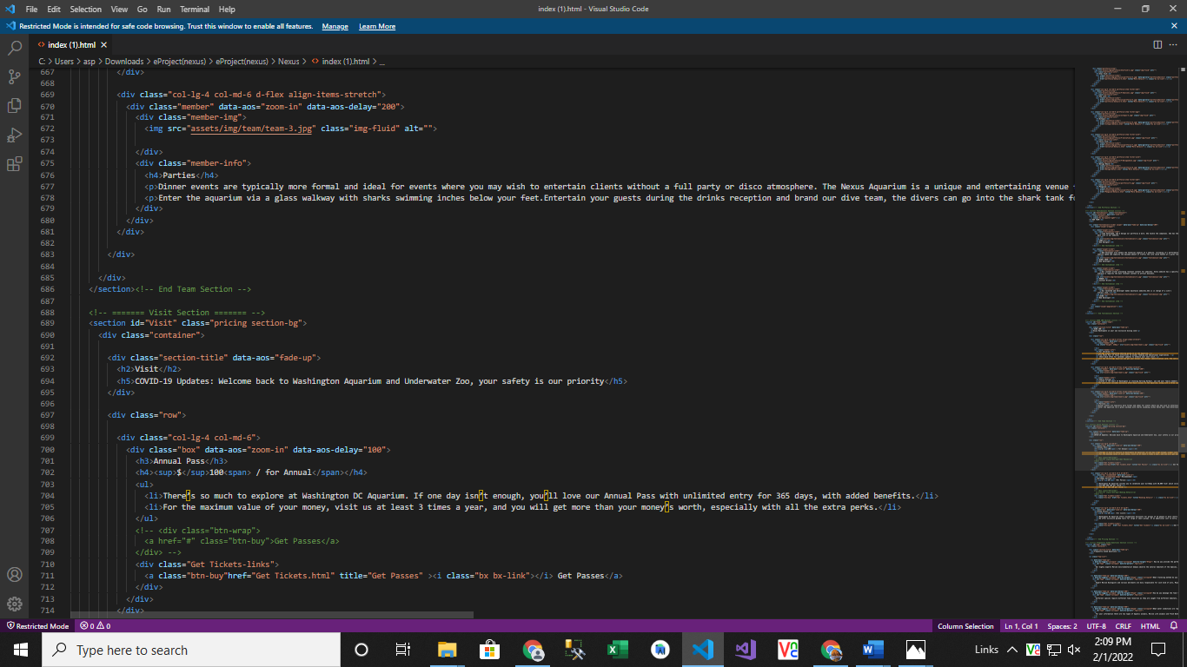
- Visit (index 91).html):

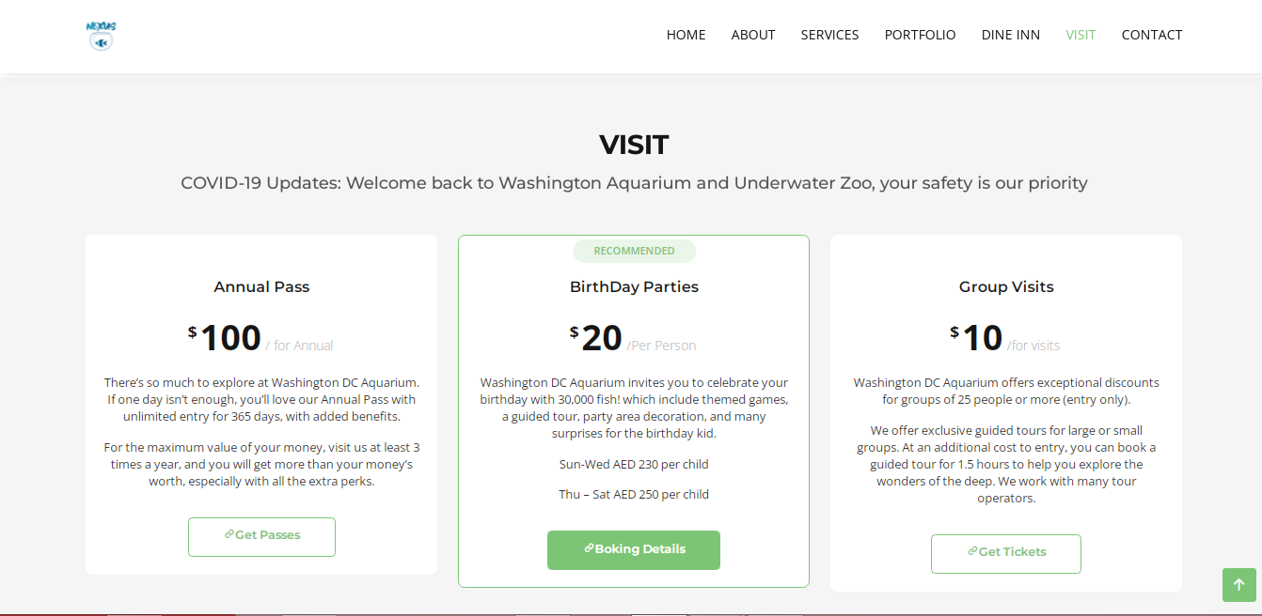
Figure 11: Visit
Visit page is about individual charges for the aquarium visit and basics description for parties and group visit.
We have given hover and link to re-direct to the ticket form for booking.

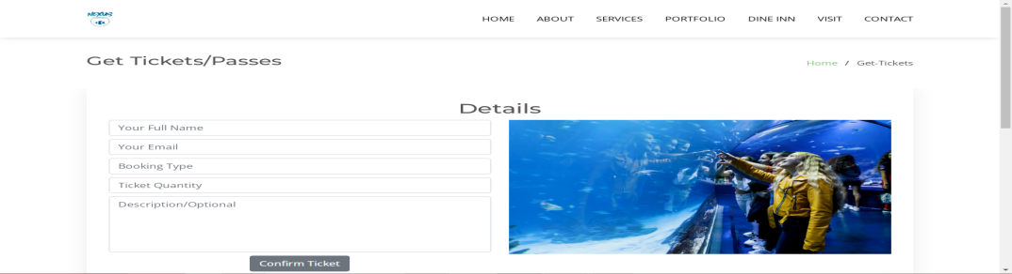

Ticket Form:
In ticket forms customer have to give details:
Your Full Name: Customer have to write their full name.
Your Email: Email won't be accepted without @ we have given validations.
Booking Type: In booking type the person have to mention about what type of passes they want to confirm.
Ticket Quantity: Number of tickets they want to confirm.
Description: Description is optional but if they want to mention any validation or request about something they can write there.

Code of Visit
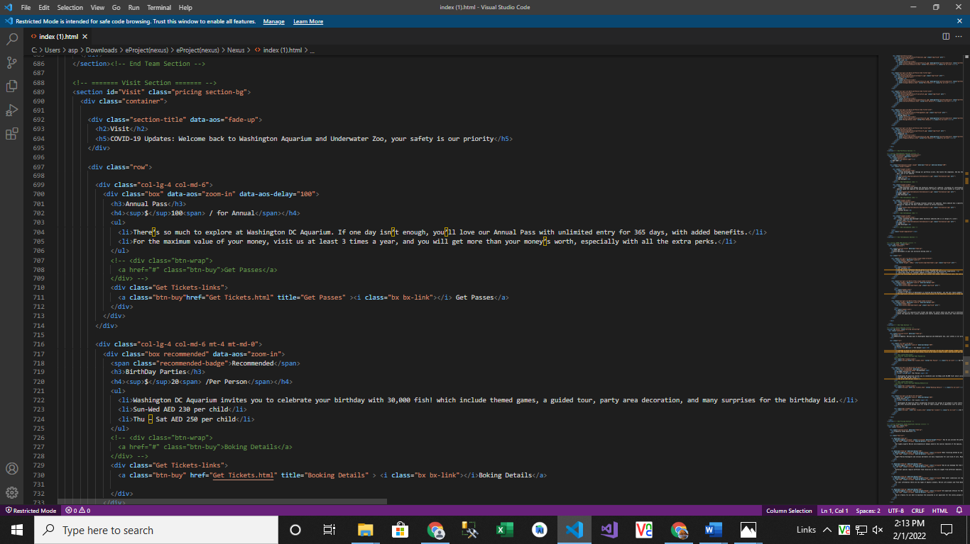
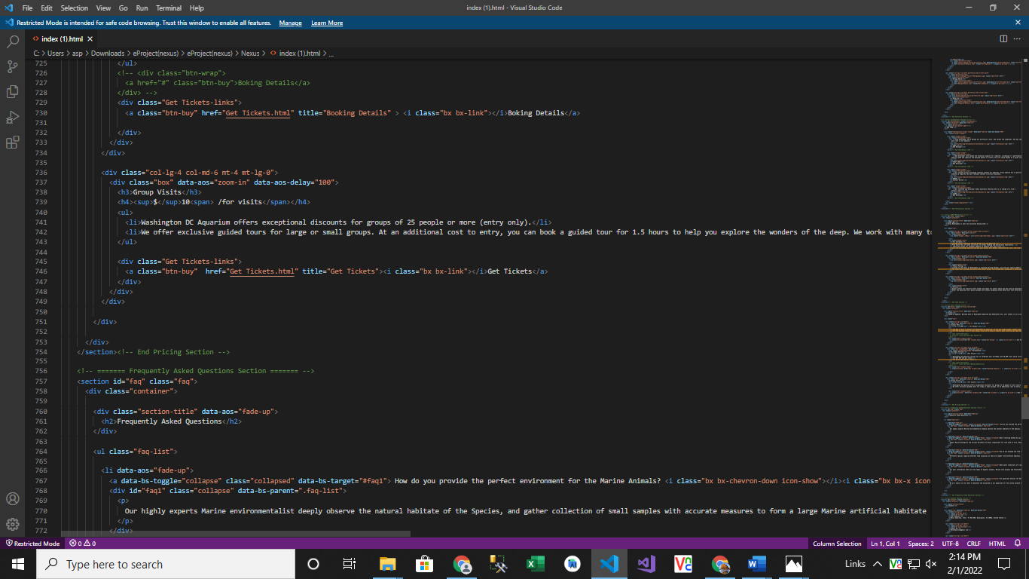

- Questions About Aquarium (index (1).html):

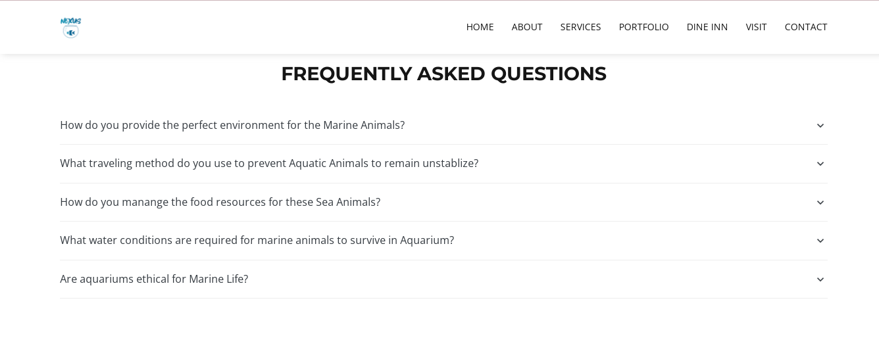
Figure 12: Questions about Aquarium
If any client has any query about our marine aquarium so they can have solutions over here.
Code of Questions
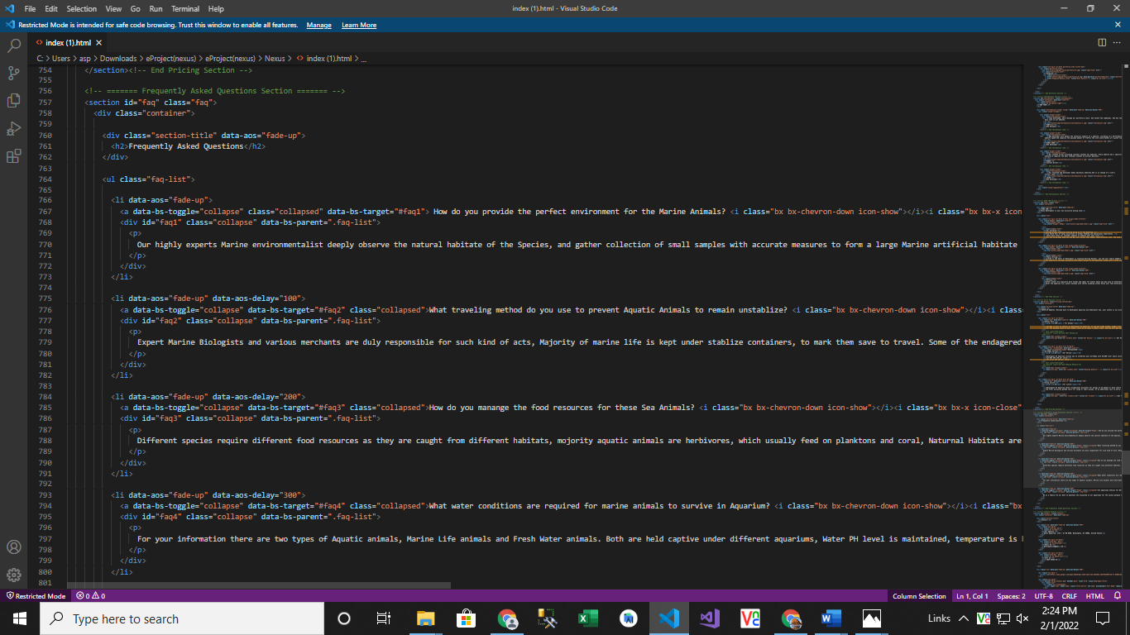
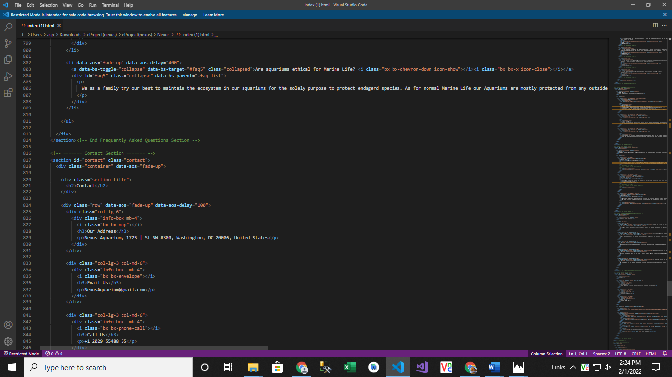

- Contact (index (1).html):

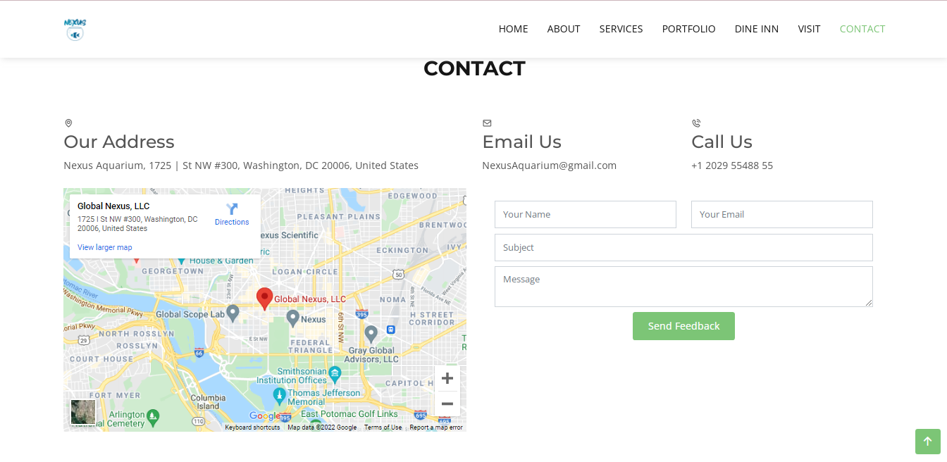
Figure 13: Contact
In our contact section we have given location map for the ease of the people
Email id and phone number for contacting in case of any problem.
Feedback Form:
To know the response of the people our team has given feedback page for the ideas and feedback of the people.

Code of Contact
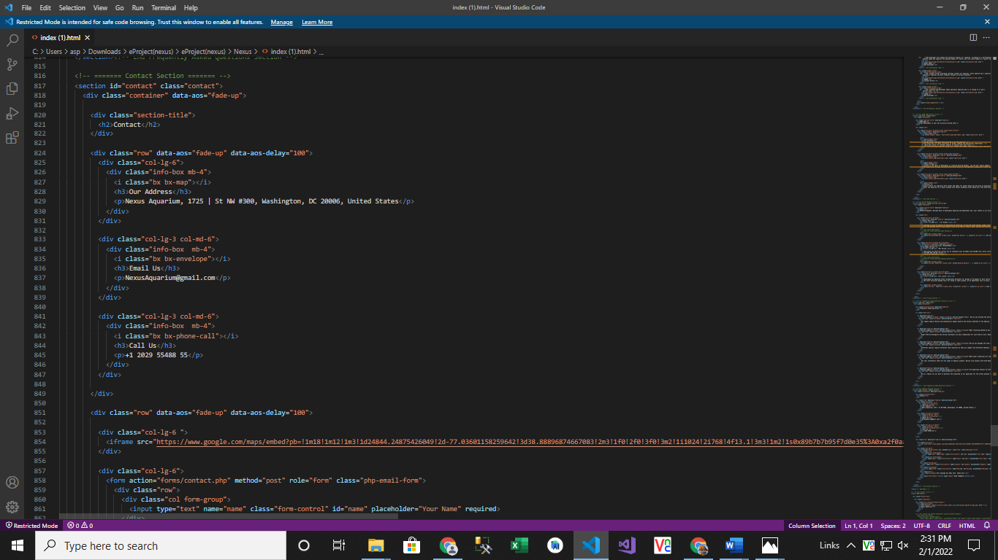
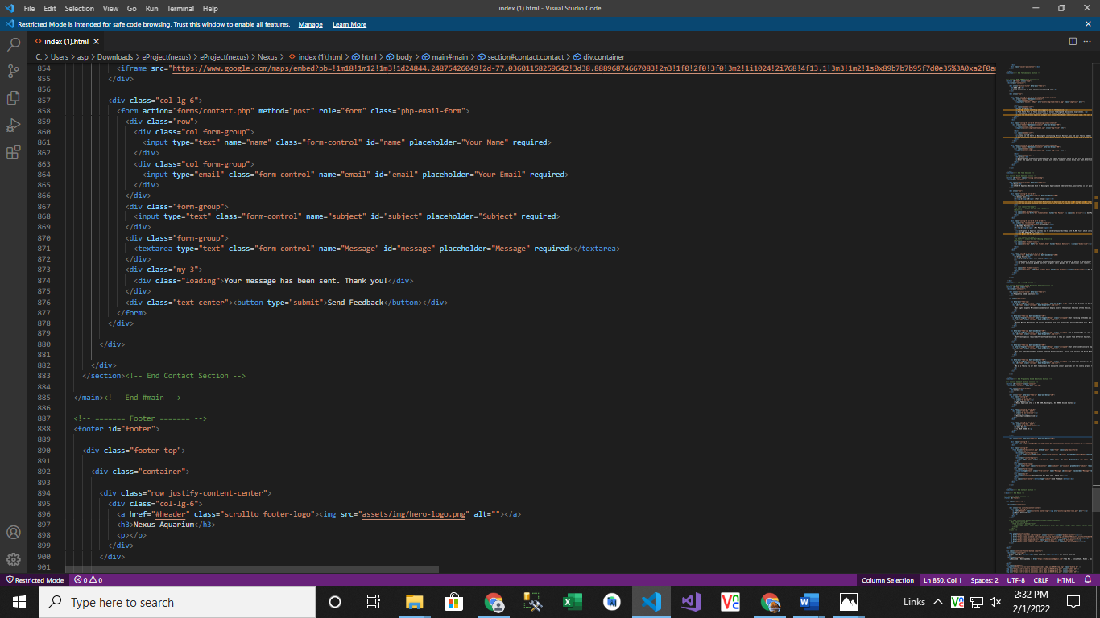

- Inner Page(inner.html):

Figure 14: Footer
We have given some water bubbles animations in footer to make our website more relaxing. Copyrights are given in the end of the website and effects of Facebook Instagram and twitter are also mentioned for making the website attractive

